**PO1_DGC_Digital**

**GDD Document**

**Version 1.2**

**Proposed**

|  |  |  |  |  |
| --- | --- | --- | --- | --- |
| **Document Change History** | | | | |
| **Version** | **Author** | **Date** | **Change** | **Status** |
| 1.0 | - Salma Amr | 29/2/2020 | * Initial creation | Draft |

|  |  |  |  |  |
| --- | --- | --- | --- | --- |
| **Document Change History** | | | | |
| **Version** | **Author** | **Date** | **Change** | **Status** |
| 1.0 | - Salma Amr | 29/2/2020 | * Initial creation | Draft |
| 1.0 | - Salma Amr | 29/2/2020 | * Initial creation * Adding project Description * Adding static architecture | Proposed |
| 1.1 | - Mira Mousa | 01/3/2020 | * Adding Software Context * Adding Input and Output Signals | Proposed |
| 1.2 | -Mohamed Nafea | 02/3/2020 | * Adding API components | Proposed |

|  |  |  |
| --- | --- | --- |
| **Reference Documents** | | |
| **Document Name** | **Version** | **Status** |
| SRS | 1.6 | Proposed |

**Table of Contents**

**1.** **Project Description** 7

**1.1** **Software Context Diagram** 7

**2.** **Input and Output Signals** 8

**2.1** **Login Verification** 8

**2.2** **Alarm Component** 9

**2.3** **Display** 10

**2.4** **Input Reading** 12

**2.5** **Elevator Motion Control** 13

**3.** **Static Architecture** 14

**3.1** **Layered Architecture** 14

**4.** **Software Components** 16

4.1 MCAL APIs 16

4.2.1 GPIO 16

4.2.1.1 GPIO Initiate 16

1. STD_ERROR GPIO_voidInit (void) 16

4.2.1.2 GPIO Set Pin Mode 16

2. - Req_PO1_DGC_GDD_002_V01 16

3. STD_ERROR GPIO_voidSetPinMode (u8 Copy_u8Port, u8 Copy_u8Pin, u8 Copy_u8Mode) 16

4.2.2.1 GPIO Set Pin Value 16

4. STD_ERROR GPIO_voidSetPinValue (u8 Copy_u8Port, u8 Copy_u8Pin, u8 Copy_u8Value) 16

4.2.2.2 GPIO Get Pin Value 17

5. STD_ERROR GPIO_u8GetPinValue (u8 Copy_u8Port, u8 Copy_u8Pin, u8 * Copy_u8Value) 17

4.2.1 Timer 17

4.2.2.3 Timer Initiate 17

- Req_PO1_DGC_GDD_005_V01 17

6. STD_ERROR TIMER_ STD_ERRORInit (void) 17

4.2.2.4 Timer Initiate 17

- Req_PO1_DGC_GDD_005_V01 17

7. STD_ERROR TIMER_ STD_ERRORInit (void) 17

4.2.2.5 Timer Set Callback 18

- Req_PO1_DGC_GDD_006_V01 18

8. STD_ERROR TIMER_ STD_ERRORSetCallback (void(* Copy_PtrCallback)(void)) 18

4.2.2.6 PWM Start 18

- Req_PO1_DGC_GDD_007_V01 18

9. STD_ERROR TIMER_ STD_ERRORPWMStart (void) 18

4.2.2.7 PWM Generate Signal 18

- Req_PO1_DGC_GDD_008_V01 18

10. STD_ERROR TIMER_ STD_ERRORPWMGenerateSignal (u16 Copy_OnPeriod, u16 Copy_TotalPeriod) 18

4.2.2.8 Timer Set Callback 19

- Req_PO1_DGC_GDD_006_V01 19

11. STD_ERROR TIMER_ STD_ERRORSetCallback (void(* Copy_PtrCallback)(void)) 19

4.2.2.9 PWM Start 19

- Req_PO1_DGC_GDD_007_V01 19

12. STD_ERROR TIMER_ STD_ERRORPWMStart (void) 19

4.2.2.10 PWM Generate Signal 19

- Req_PO1_DGC_GDD_008_V01 19

13. STD_ERROR TIMER_ STD_ERRORPWMGenerateSignal (u16 Copy_OnPeriod, u16 Copy_TotalPeriod) 19

4.2 ECUAL APIs 20

4.2.1 Switch 20

4.2.1.1 Switch Initiate 20

- Req_PO1_DGC_GDD_016_V01 20

14. STD_ERROR SWITCH_STD_ERRORInit (void) 20

4.2.1.2 Get Switch State 20

- Req_PO1_DGC_GDD_017_V01 20

15. STD_ERROR SWITCH_STD_ERRORGetSwitchState (u8 * Copy_u8PtrSwitchState) 20

4.2.2 Buzzer 21

4.2.3 LCD 21

4.2.4 Keypad 21

4.2.5 Motor 21

4.3 Application APIs 21

4.3.1 Login Verification 21

4.3.2 Alarm Component 21

4.3.3 Display 21

4.3.4 Input Reading 21

4.3.5 Elevator Motion Control 21

# **Project Description**

The major feature of the digital elevator as listed below:

* Check if the user is signed in/up or not.
* Check the limit number of users (maximum number of users is 10).
* Display the status using a user-friendly interface.
* Require the password and user ID.
* Two buttons to control the system:

1. Button for up movement.
2. Button for down movement.
3. Button for on/off and reset the system.

## **Software Context Diagram**

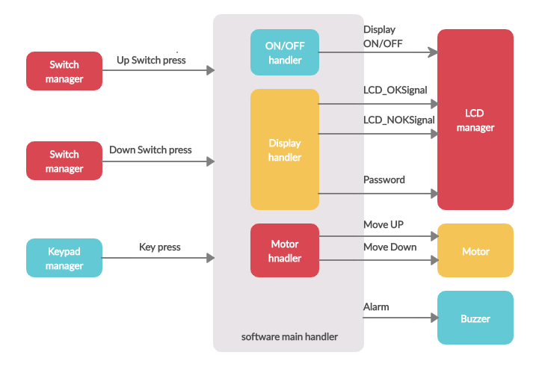

Figure 1| Software context diagram

# **Input and Output Signals**

The input and output signals in the project are listed below in figures, with explained information about each signal.

## **Login Verification**

**Input signals:** UserID_Signal, UserPass_Signal.

**Output signals:** LoggedInAccepted_Signal, LoggedInRejected_Signal.

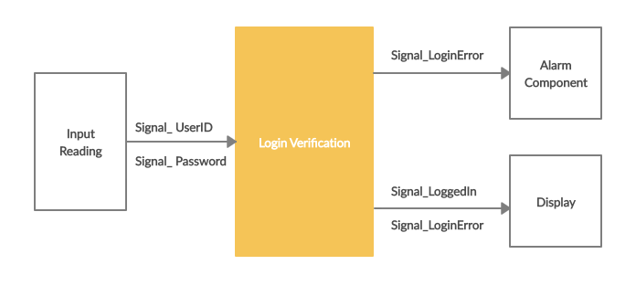

Figure 2| Login Verification Control Signals

|  |  |  |  |  |
| --- | --- | --- | --- | --- |
| UserID_Signal | |  | UserPass_Signal | |
| **Range** | [a-z,A-Z] |  | **Range** | [0000,9999] |
| **Unit** | NA |  | **Unit** | NA |
|  |  |  |  |  |
| LoggedInAccepted_Signal | |  | LoggedInRejected_Signal | |
| **Range** | [1] |  | **Range** | [0] |
| **Unit** | NA |  | **Unit** | NA |

## **Alarm Component**

**Input signals:** LoggedInRejected_Signal.

**Output signals:** BUZZERON_Signal.

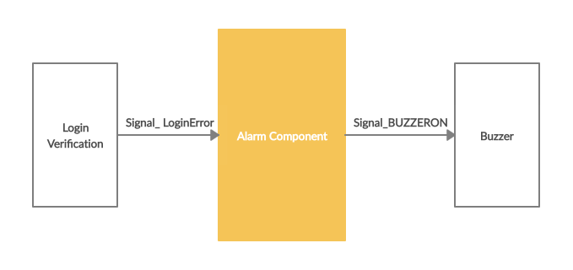

*Figure ‎2-2Alarm Component Control Signals*

|  |  |  |  |  |
| --- | --- | --- | --- | --- |
| BUZZERON_Signal | |  | LoggedInRejected_Signal | |
| **Range** | [0,1] |  | **Range** | [0] |
| **Unit** | NA |  | **Unit** | NA |

## **Display**

**Input signals:** Signal_ UserID, Signal_ Password, Signal_LoggedIn, Signal_LoginError.

**Output signals:** Signal_Display, Signal_LCDOK, Signal_LCDNOK.

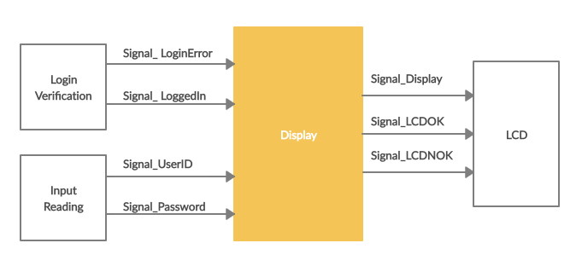

*Figure ‎2-3Display Control Signals*

|  |  |  |  |  |
| --- | --- | --- | --- | --- |
| Signal_ LoggedIn | |  | LoggedInRejected_Signal | |
| **Range** | [1] |  | **Range** | [0] |
| **Unit** | NA |  | **Unit** | NA |
|  | |
| Signal_ UserID | |  | Signal_ Password | |
| **Range** | [A,C] |  | **Range** | [0000,9999] |
| **Unit** | NA |  | **Unit** | NA |
|  | |
| Signal_ Display | |  | Signal_ LCDNOK | |
| **Range** | [0,1] |  | **Range** | [0] |
| **Unit** | NA |  | **Unit** | NA |
|  | |
| Signal_ LCDOK | |  |  | |
| **Range** | [1] |  |  |  |
| **Unit** | NA |  |  |  |

## **Input Reading**

**Input signals:** Signal_KeypadPressed.

**Output signals:** Signal_ UserID, Signal_ Password.

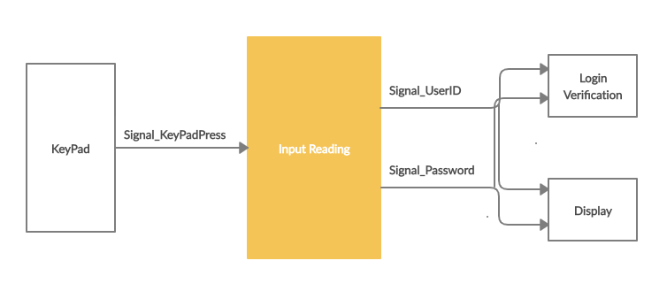

*Figure ‎2-4Input ReadingControl Signals*

|  |  |  |  |  |
| --- | --- | --- | --- | --- |
| Signal_ UserID | |  | Signal_ Password | |
| **Range** | [A,C] |  | **Range** | [0000,9999] |
| **Unit** | NA |  | **Unit** | NA |
|  |  |  |  |  |
| Signal_ KeyPadPress | |  |  | |
| **Range** | [0,9 and A,C] |  |  |  |
| **Unit** | NA |  |  |  |

## **Elevator Motion Control**

**Input signals:** Signal_UpSwitchPressed, Signal_DownSwitchPressed.

**Output signals:** Signal_ MotorUp, Signal_MotorDown.

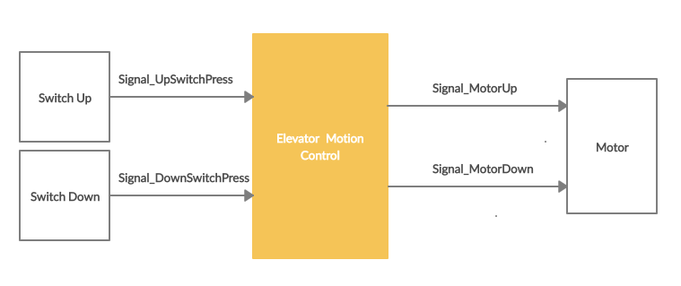*Figure ‎2-5Elevator Motion Control Signals*

|  |  |  |  |  |
| --- | --- | --- | --- | --- |
| Signal_UpSwitchPress | |  | Signal_ DownSwitchPress | |
| **Range** | [0,1] |  | **Range** | [0,1] |
| **Unit** | NA |  | **Unit** | NA |
|  | |
| Signal_ MotorDown | |  | Signal_ MotorUp | |
| **Range** | [00 or 01] |  | **Range** | [00 or 10] |
| **Unit** | NA |  | **Unit** | NA |

# **Static Architecture**

## **Layered Architecture**

The layered architecture represents the architecture of the project as separate horizontal layers, and shows the dependency of each module in any layer on other modules as shown in Figure ‎3.

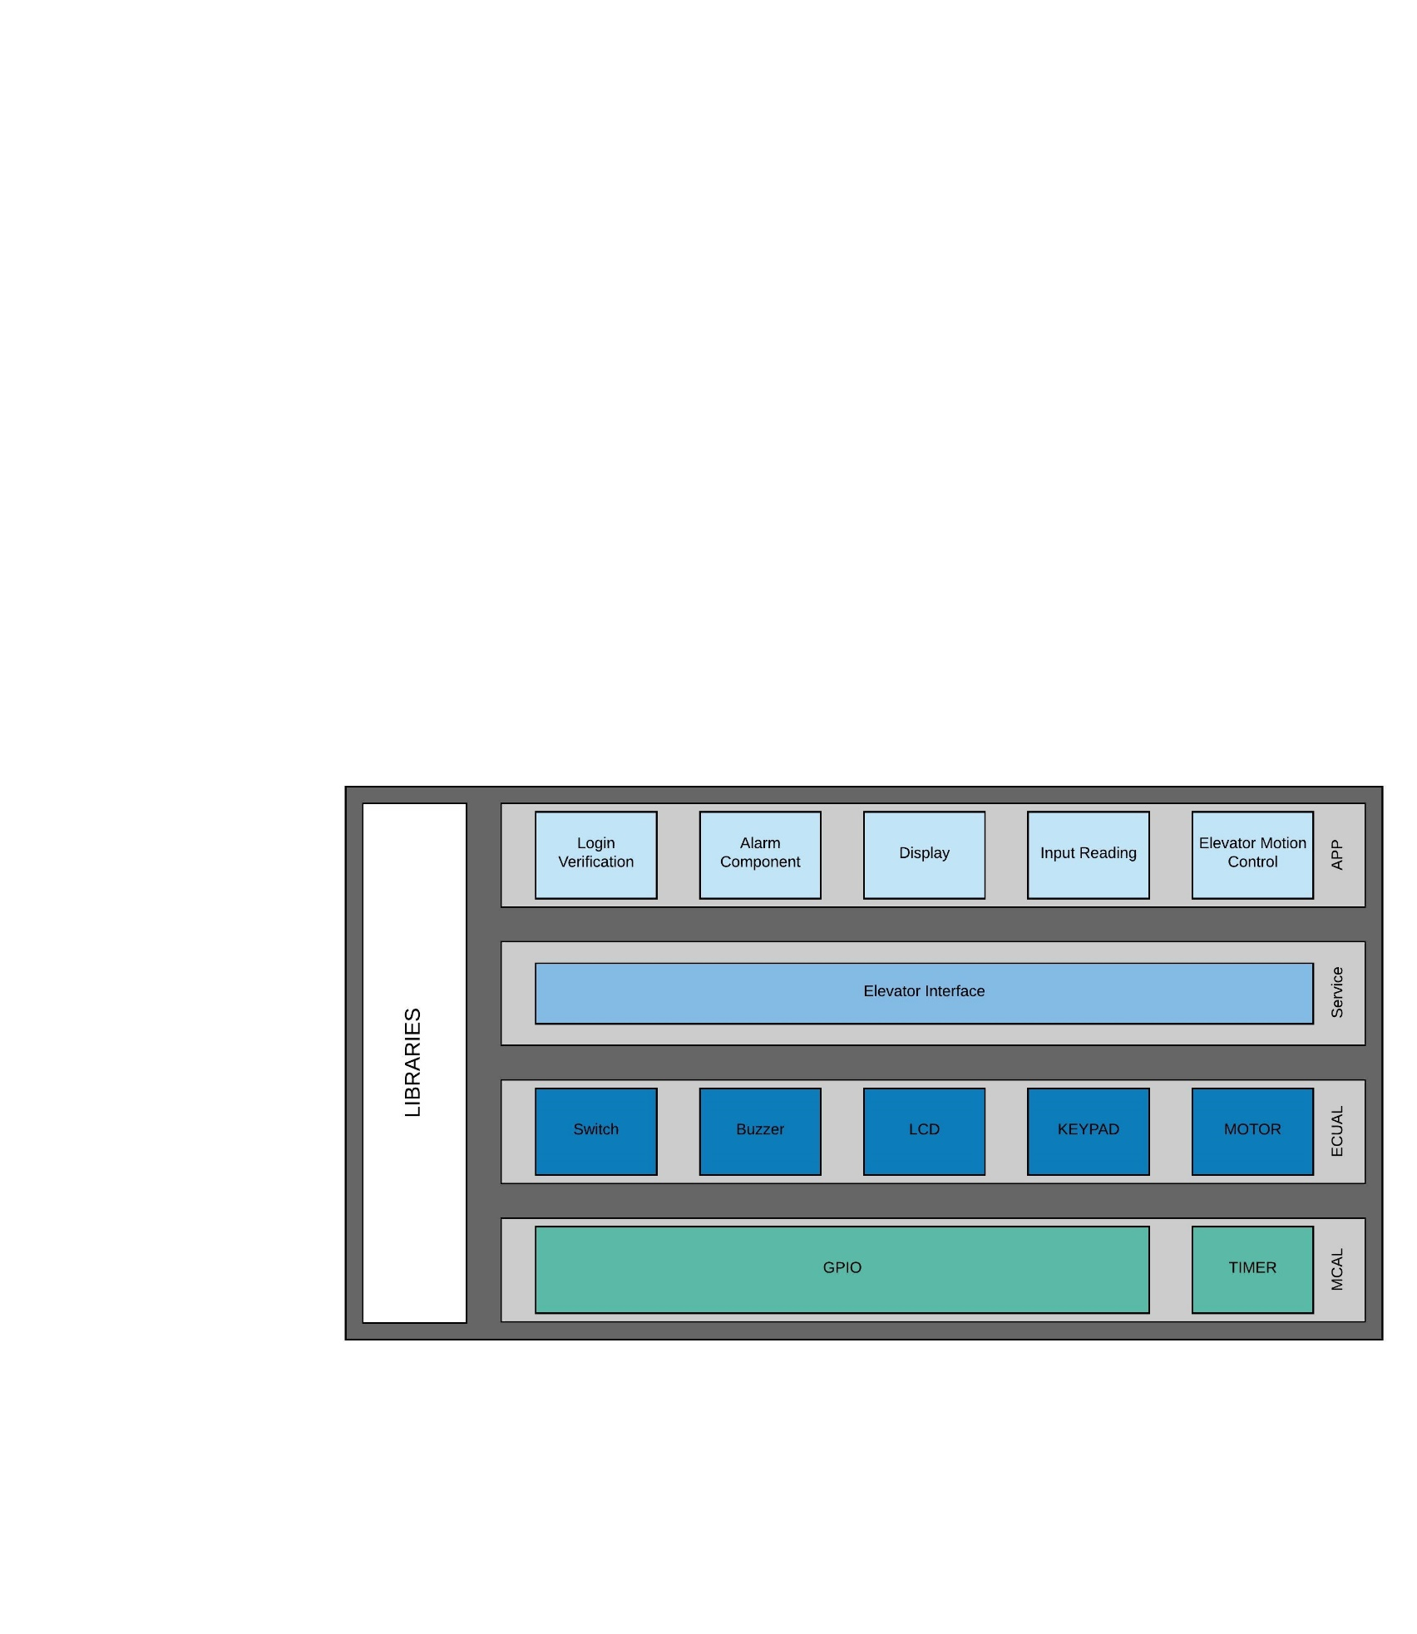

Figure 3| Project Layered Architecture

# **Software Components**

## MCAL APIs

### 4.1.1 GPIO

#### GPIO Initialize

|  |  |
| --- | --- |
| Requirement ID | Req_PO1_DGELV_GDD_001_V01.2 |
| API | STD_ERROR GPIO_voidInit (void) |
| Description | This API shall initialize GPIO pins with initial values or configured values if exists |
| Arguments | * void |
| Return | * STD_ERROR that holds the error state of the API implementation, it shall be 0 for OK if everything is done correctly, and 1 for NOK if anything goes wrong. |
| Covers | * NA |

#### GPIO Set Pin Mode

|  |  |
| --- | --- |
| Requirement ID | Req_PO1_DGELV_GDD_002_V01.2 |
| API | STD_ERROR GPIO_voidSetPinMode (u8 Copy_u8Port, u8 Copy_u8Pin, u8 Copy_u8Mode) |
| Description | This API shall set pin mode as input or output |
| Arguments | * Copy_u8Port: specifies pin’s port, which shall be one of this options: A, B, C, D * Copy_u8Pin: specifies pin number, which shall be number in this range: [0-7] * Copy_u8Mode: specifies pin mode, which is 0 for input and 1 for output |
| Return | * STD_ERROR that holds the error state of the API implementation, it shall be 0 for OK if everything is done correctly, and 1 for NOK if anything goes wrong. |
| Covers | * NA |

#### GPIO Set Pin Value

|  |  |
| --- | --- |
| Requirement ID | Req_PO1_DGELV_GDD_003_V01.2 |
| API | STD_ERROR GPIO_voidSetPinValue (u8 Copy_u8Port, u8 Copy_u8Pin, u8 Copy_u8Value) |
| Description | This API shall set pin value |
| Arguments | Copy_u8Port: specifies pin’s port, which shall be one of this options: A, B, C, DCopy_u8Pin: specifies pin number, which shall be number in this range: [0-7]Copy_u8Mode: specifies value set to the pin, which shall be 0 or 1 |
| Return | STD_ERROR that holds the error state of the API implementation, it shall be 0 for OK if everything is done correctly, and 1 for NOK if anything goes wrong. |
| Covers | NA |

#### GPIO Get Pin Value

|  |  |
| --- | --- |
| Requirement ID | Req_PO1_DGELV_GDD_002_V01.2 |
| API | STD_ERROR GPIO_u8GetPinValue (u8 Copy_u8Port, u8 Copy_u8Pin, u8 * Copy_u8Value) |
| Description | This API shall get pin value |
| Arguments | Copy_u8Port: specifies pin’s port, which shall be one of this options: A, B, C, DCopy_u8Pin: specifies pin number, which shall be number in this range: [0-7]Copy_u8Value: pointer that holds the value of the pin, it shall be 0 or 1 |
| Return | STD_ERROR that holds the error state of the API implementation, it shall be 0 for OK if everything is done correctly, and 1 for NOK if anything goes wrong. |

### Timer

#### Timer Initiate

|  |  |
| --- | --- |
| Requirement ID | Req_PO1_DGC_GDD_005_V01 |
| API | STD_ERROR TIMER_ STD_ERRORInit (void) |
| Description | This API shall initiate timer |
| Arguments | * void |
| Return | * STD_ERROR that holds the error state of the API implementation, it shall be 0 for OK if everything is done correctly, and 1 for NOK if anything goes wrong. |
| Covers | * NA |

#### Timer Initiate

|  |  |
| --- | --- |
| Requirement ID | Req_PO1_DGC_GDD_005_V01 |
| API | STD_ERROR TIMER_ STD_ERRORInit (void) |
| Description | This API shall initiate timer |
| Arguments | * void |
| Return | * STD_ERROR that holds the error state of the API implementation, it shall be 0 for OK if everything is done correctly, and 1 for NOK if anything goes wrong. |
| Covers | * NA |

#### Timer Set Callback

|  |  |
| --- | --- |
| Requirement ID | Req_PO1_DGC_GDD_006_V01 |
| API | STD_ERROR TIMER_ STD_ERRORSetCallback (void(* Copy_PtrCallback)(void)) |
| Description | This API shall set call back function of timer interrupt |
| Arguments | * Copy_PtrCallback: pointer that holds the address of callback function |
| Return | * STD_ERROR that holds the error state of the API implementation, it shall be 0 for OK if everything is done correctly, and 1 for NOK if anything goes wrong. |
| Covers | * NA |

#### PWM Start

|  |  |
| --- | --- |
| Requirement ID | Req_PO1_DGC_GDD_007_V01 |
| API | STD_ERROR TIMER_ STD_ERRORPWMStart (void) |
| Description | This API shall start PWM by setting callback function related to PWM |
| Arguments | * void |
| Return | * STD_ERROR that holds the error state of the API implementation, it shall be 0 for OK if everything is done correctly, and 1 for NOK if anything goes wrong. |
| Covers | * NA |

#### PWM Generate Signal

|  |  |
| --- | --- |
| Requirement ID | Req_PO1_DGC_GDD_008_V01 |
| API | STD_ERROR TIMER_ STD_ERRORPWMGenerateSignal (u16 Copy_OnPeriod, u16 Copy_TotalPeriod) |
| Description | This API shall generate PWM signal by setting its On period, total period and peak value |
| Arguments | * Copy_OnPeriod: specifies the duration of the On part of the period * Copy_TotalPeriod: specifies the duration of the total period |
| Return | * STD_ERROR that holds the error state of the API implementation, it shall be 0 for OK if everything is done correctly, and 1 for NOK if anything goes wrong. |
| Covers | * NA |

#### Timer Set Callback

|  |  |
| --- | --- |
| Requirement ID | Req_PO1_DGC_GDD_006_V01 |
| API | STD_ERROR TIMER_ STD_ERRORSetCallback (void(* Copy_PtrCallback)(void)) |
| Description | This API shall set call back function of timer interrupt |
| Arguments | * Copy_PtrCallback: pointer that holds the address of callback function |
| Return | * STD_ERROR that holds the error state of the API implementation, it shall be 0 for OK if everything is done correctly, and 1 for NOK if anything goes wrong. |
| Covers | * NA |

#### PWM Start

|  |  |
| --- | --- |
| Requirement ID | Req_PO1_DGC_GDD_007_V01 |
| API | STD_ERROR TIMER_ STD_ERRORPWMStart (void) |
| Description | This API shall start PWM by setting callback function related to PWM |
| Arguments | * void |
| Return | * STD_ERROR that holds the error state of the API implementation, it shall be 0 for OK if everything is done correctly, and 1 for NOK if anything goes wrong. |
| Covers | * NA |

#### PWM Generate Signal

|  |  |
| --- | --- |
| Requirement ID | Req_PO1_DGC_GDD_008_V01 |
| API | STD_ERROR TIMER_ STD_ERRORPWMGenerateSignal (u16 Copy_OnPeriod, u16 Copy_TotalPeriod) |
| Description | This API shall generate PWM signal by setting its On period, total period and peak value |
| Arguments | * Copy_OnPeriod: specifies the duration of the On part of the period * Copy_TotalPeriod: specifies the duration of the total period |
| Return | * STD_ERROR that holds the error state of the API implementation, it shall be 0 for OK if everything is done correctly, and 1 for NOK if anything goes wrong. |
| Covers | * NA |

## 4.2 ECUAL APIs

### Switch

#### 4.2.1.1 Switch Initiate

|  |  |
| --- | --- |
| Requirement ID | Req_PO1_DGC_GDD_016_V01 |
| API | STD_ERROR SWITCH_STD_ERRORInit (void) |
| Description | This API shall initiate switch on its configured pins |
| Arguments | * void |
| Return | * STD_ERROR that holds the error state of the API implementation, it shall be 0 for OK if everything is done correctly, and 1 for NOK if anything goes wrong. |
| Covers | * NA |

#### Get Switch State

|  |  |
| --- | --- |
| Requirement ID | Req_PO1_DGC_GDD_017_V01 |
| API | STD_ERROR SWITCH_STD_ERRORGetSwitchState (u8 * Copy_u8PtrSwitchState) |
| Description | This API shall get the switch state |
| Arguments | * Copy_u8PtrSwitchState: pointer that holds the switch state, it shall be 1 if switch is pressed and 0 if switch is released. |
| Return | * STD_ERROR that holds the error state of the API implementation, it shall be 0 for OK if everything is done correctly, and 1 for NOK if anything goes wrong. |
| Covers | * NA |

### Buzzer

#### Buzzer Initiate

|  |  |
| --- | --- |
| Requirement ID | Req_PO1_DGC_GDD_018_V01 |
| API | STD_ERROR BUZZER_STD_ERRORInit (void) |
| Description | This API shall initiate buzzer on its configured pins |
| Arguments | * void |
| Return | * STD_ERROR that holds the error state of the API implementation, it shall be 0 for OK if everything is done correctly, and 1 for NOK if anything goes wrong. |
| Covers | * NA |

#### Run Buzzer

|  |  |
| --- | --- |
| Requirement ID | Req_PO1_DGC_GDD_019_V01 |
| API | STD_ERROR BUZZER_STD_ERRORRunBuzzer (u16 Copy_u16Frequency, u8 Copy_u8Duty) |
| Description | This API shall run buzzer for specific frequency in specific duty cycle |
| Arguments | * Copy_u16Frequency: specifies the buzzer frequency, it shall be 250 or 500 Hz * Copy_u8Duty: specifies the percentage of duty cycle |
| Return | * STD_ERROR that holds the error state of the API implementation, it shall be 0 for OK if everything is done correctly, and 1 for NOK if anything goes wrong. |
| Covers | * NA |

### LCD

#### LCD Initiate

|  |  |
| --- | --- |
| Requirement ID | Req_PO1_DGC_GDD_011_V01 |
| API | STD_ERROR LCD_STD_ERRORInit (void) |
| Description | This API shall initiate LCD configurations |
| Arguments | * void |
| Return | * STD_ERROR that holds the error state of the API implementation, it shall be 0 for OK if everything is done correctly, and 1 for NOK if anything goes wrong. |
| Covers | * NA |

#### LCD Write Data

|  |  |
| --- | --- |
| Requirement ID | Req_PO1_DGC_GDD_012_V01 |
| API | STD_ERROR LCD_STD_ERRORWriteString (u8 * Copy_u8PtrString) |
| Description | This API shall display string on LCD |
| Arguments | * Copy_u8PtrString: pointer that holds the string value |
| Return | * STD_ERROR that holds the error state of the API implementation, it shall be 0 for OK if everything is done correctly, and 1 for NOK if anything goes wrong. |
| Covers | * NA |

#### LCD Write Command

|  |  |
| --- | --- |
| Requirement ID | Req_PO1_DGC_GDD_013_V01 |
| API | STD_ERROR LCD_STD_ERRORWriteCmd (u8 Copy_u8Cmd) |
| Description | This API shall send command to LCD |
| Arguments | * Copy_ u8Cmd: specifies command to be sent to LCD |
| Return | * STD_ERROR that holds the error state of the API implementation, it shall be 0 for OK if everything is done correctly, and 1 for NOK if anything goes wrong. |
| Covers | * NA |

#### LCD Go to Location

|  |  |
| --- | --- |
| Requirement ID | Req_PO1_DGC_GDD_014_V01 |
| API | STD_ERROR LCD_STD_ERRORGoToLocation (u8 Copy_u8Line, u8 Copy_u8Position) |
| Description | This API shall set LCD cursor at specific line and position |
| Arguments | * Copy_ u8Line: specifies line of the cursor, it shall be 1 or 2 * Copy_ u8Position: specifies position of the cursor in the line, it shall be in the range [0-15] |
| Return | * STD_ERROR that holds the error state of the API implementation, it shall be 0 for OK if everything is done correctly, and 1 for NOK if anything goes wrong. |
| Covers | * NA |

#### LCD Clear

|  |  |
| --- | --- |
| Requirement ID | Req_PO1_DGC_GDD_015_V01 |
| API | STD_ERROR LCD_STD_ERRORClear (void) |
| Description | This API shall clear the display of LCD |
| Arguments | * void |
| Return | * STD_ERROR that holds the error state of the API implementation, it shall be 0 for OK if everything is done correctly, and 1 for NOK if anything goes wrong. |
| Covers | * NA |

### Keypad

#### Keypad Initiate

|  |  |
| --- | --- |
| Requirement ID | Req_PO1_DGC_GDD_009_V01 |
| API | STD_ERROR KEYPDAD_STD_ERRORInit (void) |
| Description | This API shall initiate keypad on its configured pins |
| Arguments | * void |
| Return | * STD_ERROR that holds the error state of the API implementation, it shall be 0 for OK if everything is done correctly, and 1 for NOK if anything goes wrong. |
| Covers | * NA |

#### Keypad Get Pressed Key

|  |  |
| --- | --- |
| Requirement ID | Req_PO1_DGC_GDD_010_V01 |
| API | STD_ERROR KEYPDAD_STD_ERRORGetKeyPressed (u8 * Copy_u8PtrKey) |
| Description | This API shall get the keypad pressed key |
| Arguments | * Copy_u8PtrKey: pointer that holds the value of the pressed key |
| Return | * STD_ERROR that holds the error state of the API implementation, it shall be 0 for OK if everything is done correctly, and 1 for NOK if anything goes wrong. |
| Covers | * NA |

### 4.2.5 Motor

## 4.3 Application APIs

### 4.3.1 Login Verification

### 4.3.2 Alarm Component

### 4.3.3 Display

### Input Reading

### Elevator Motion Control